One to many relationship

User Entity

Vehicle Entity

A user can have many vehicles and many vehicles belong to one user

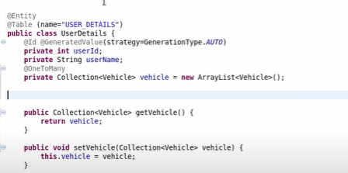

We have a user entity

User entity in it will have many vehicles so we make a Collection of vehicles and declare them as an arraylist so that it is not null.not make getters and setters for it

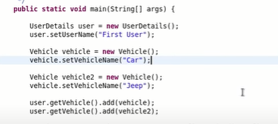

Now as above we will make two vehicle objects and add it to user entity

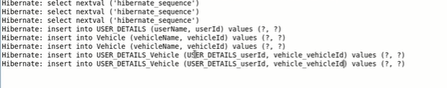

As we can see above in this scenario hibernate has created a new table:

USER_DETAILS(one to many)

|  |  |
| --- | --- |
| userId | userName |
| 1 | A |
| 2 | B |
| 3 | C |

Vehicle

|  |  |
| --- | --- |
| vehicleId | vehicleName |
| 1 | Car |
| 2 | Jeep |
| 3 | Bus |

USER_DETAILS_ Vehicle

|  |  |
| --- | --- |
| USER_DETAILS_userId | Vehicle_vehicleId |
| 1 | 1 |
| 1 | 2 |
| 1 | 3 |
|  |  |

Now we have changed the name of the table as well as the columns of the table:

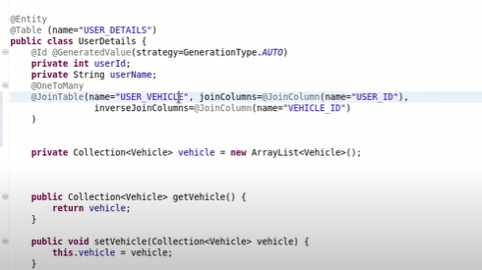

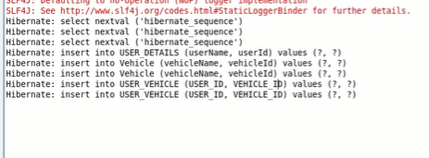

**Many to one**

In case we want the vehicle to give us back the user name then we can use a many to one relationship because many vehicles can belong to a single user.

